**CorEssentials**

**Assembly Manual**

Document Version: V0.1

**Inhaltsverzeichnis**

1 CorEssentials Overview 3

2 Preparation 7

2.1 Thread Tapping 7

2.2 Threaded inserts 7

3 Assembly of Motion Systems 8

3.1 XY-Gantry 8

3.2 X-carriage 16

3.3 Tool Head 19

3.4 Z-Motion Stage 21

3.5 Bed Assembly 27

4 Frame Assembly 29

4.1 Main Frame 29

# CorEssentials Overview

This is a quick teaser of the technical data & specification for the CorEssentials 3D printer. You can view the current 3D model here:

[CorEssentials Fusion360 Model (view only until full release)](https://a360.co/2q4ACzH)

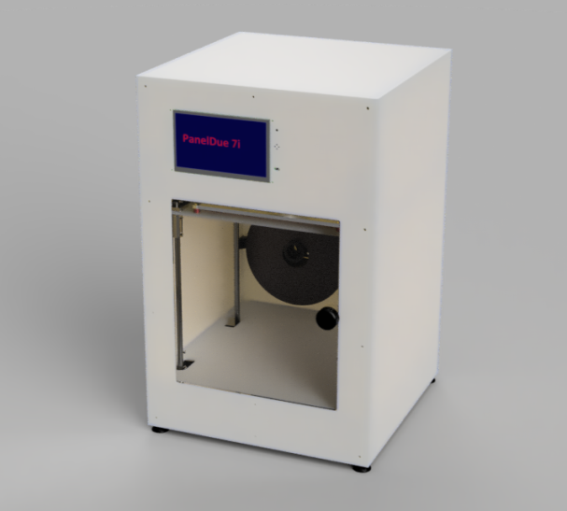

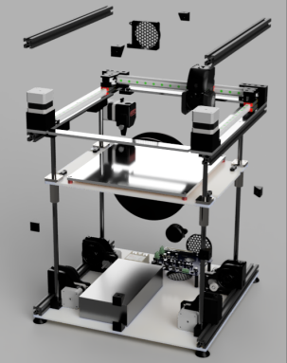

**Built Volume:** 240 mm x 250 x mm x 250 mm

**Hotend:** E3D V6

**Extruder:** Bondtech BMG

**Built Plate:** Magnetic Spring Steel

**Built Surface:** PEI or PERTINAX

**Heated Bed:**  up to 120°C (230V, 600W)

**Connectivity:** 7" Touchscreen, USB, Ethernet

**Bed Leveling:** Hardware bed leveling with 4 independent motors

**Filament runout detection: microswitch or Duet Magnetic Filament Monitor**

**Enclosure:** Completely enclosed print volume with active temperature regulation and passive heated chamber (through heated bed), LED illumination

[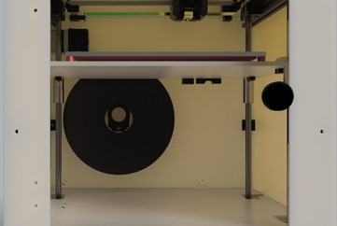](javascript:;)

**Open for all Filaments**

**Filament Diameter:** 1.75mm

**Supported Filament:** ABS, ASA, PC, Nylon, PETG, PLA, PP, HIPS

carbon and particle filled filaments possible with appropriate toolhead

[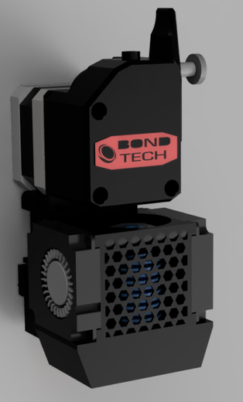](javascript:;)

derived from VORON V2.2, 100% compatible

E3D V6 40 Watt Heater

quick-swapp with 2 screws and 1 connector

direct or bowden tool available

[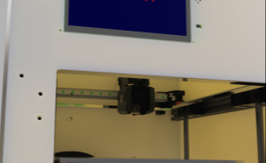](javascript:;)

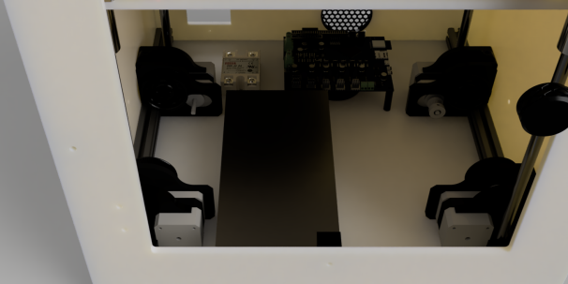

**Controller:** Duet 2 Maestro with a total of 7 stepper drivers

**Heated bed:** KEENOVO 230V 600W heater

**Power Supply:** Meanwell 24V >10A

**Coldend cooling:** 4010 axial fan

**Part cooling:** 2x 4010 blower fan

**Chamber filtration:** 6025 axial fan

**Electronics cooling:** 2x 6025 axial fan

Linear Motion: CE MGN9H for xy gantry and 10mm rods for z

**Belt driven z axis**

**Completely open source:** all Fusion 360 files and .stp assembly available

# Preparation

## Thread Tapping

Thread tapping with M4 and M5 thread:

* 4 times M4 thread in 2010 aluminium extrusion (both ends)
* 12 times M5 thread in 2020 aluminium extrusion (both ends)

## Threaded inserts

Prepare and install M3 threaded inserts

[Threaded insert guide on youtube](https://www.youtube.com/watch?v=oKfRmUJ1J-s)

* Fan Cover Chamber – 4x M3x12x4
* Extruder Mount – 2x M3x6x4
* Nozzle Cleaner – 1x M3x6x4
* X-Carriage Right – 5x M3x6x4 (2x Probe, 1x lower, 1x upper, 1x strain relief), 1x M3x12x4 (tool mount)
* X-Carriage Left – 1x M3x12x4 (tool mount)
* Y-Carriage Right – 1x M3x6x4
* Z-Drive Counter Plate – 3x M3x6x4 (each)
* Z-Drive Counter Plate MIRR – 3x M3x6x4 (each)
* Z-Dragchain Mount – 2x M3x6x4
* Z-Endstop – 2x M3x6x4

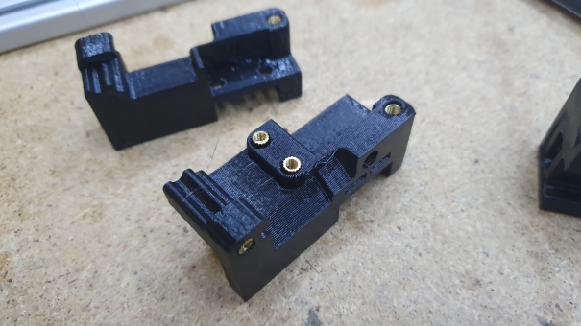

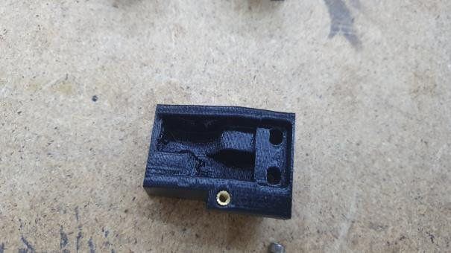

# Assembly of Motion Systems

## XY-Gantry

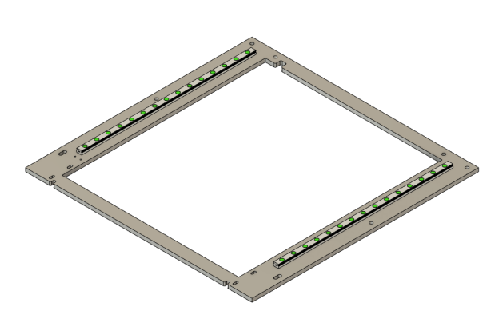

16x M3x12 Socket head

16x M3 washer

16x M3 hex nuts

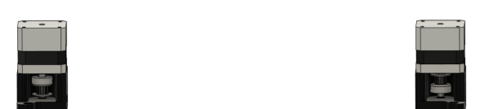

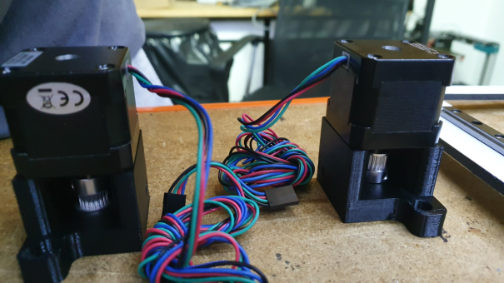

2x GT2 20T pulley

2x Nema17 40mm

4x M3x30 Cap Head

1x xy Motor Mount Left

1x xy Motor Mount Left

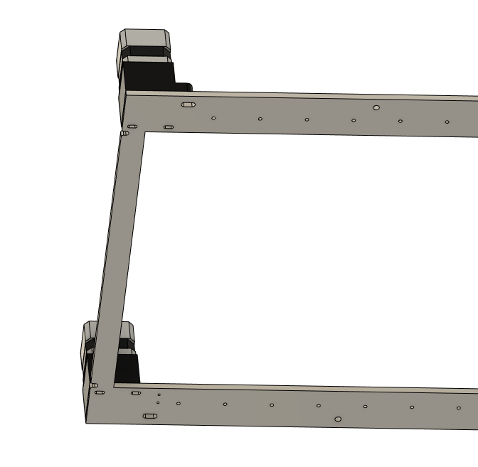

4x M3x45

4x M3 Washer

2x M5x16 Cap Head (will be fixed later)

Do not tighten, needs to move

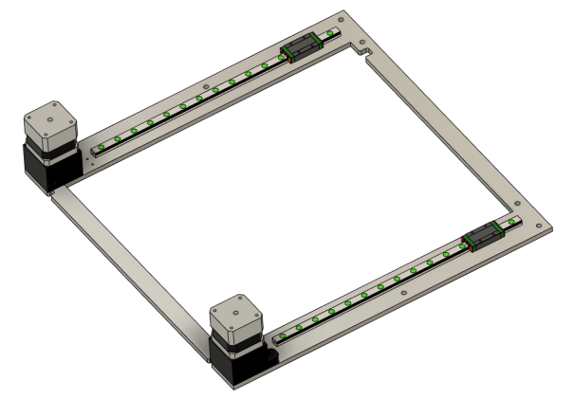

2x MGN9H carriages, carfully to not loose balls

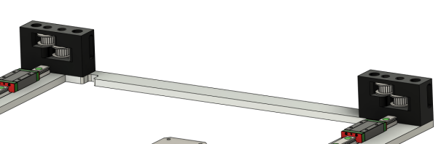

1x xy idler right

1x xy idler left

4x GT2 20T B3 pulley

4x M3x35 counter sunk

2x M3x45 socket head screw

2x M5x50 counter sunk screw (will be fixed in next step)

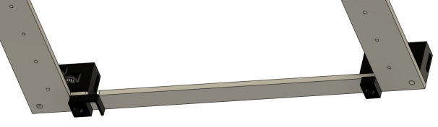

2x M5 hex Nuts

1x xy anchor

1x xy anchor cable clip

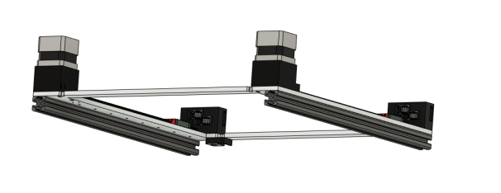

2x 2020x390mm aluminium extrusion with

6x M5-T slot nut on top

2x M5x12 button head

Fix 4 remaining screws from xy idler and xy-motor mounts. You should still be able to move the motor mounts for and backwards to later tension the belts

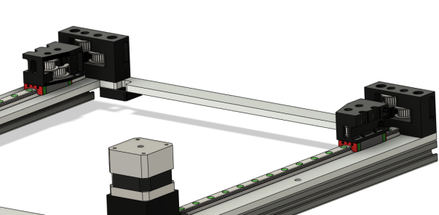

1x XY carriage left

1x xy-carriage right

2 GT2 20T idler B3 with teeth

2 GT2 20T idler B3 without teeth – right side: lower pulley, left side: upper pulley

2x M3x12 cap head screw

2x M3x6 countersunk screws

1x 2010 extrusion

4x M4x20 countersunk screws

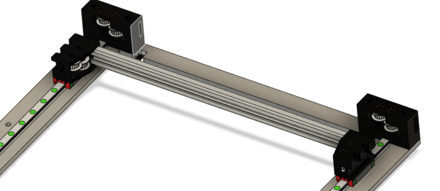

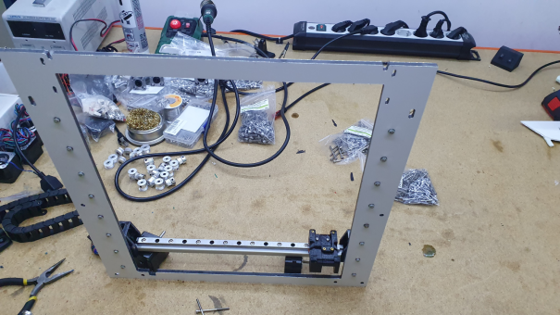

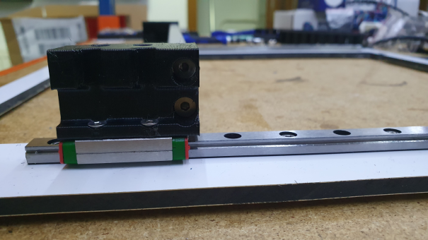

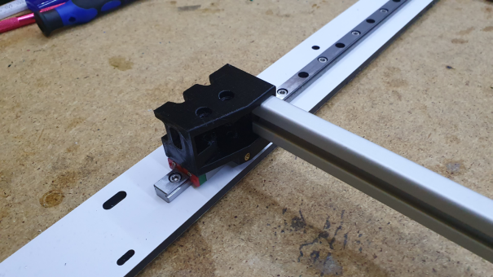

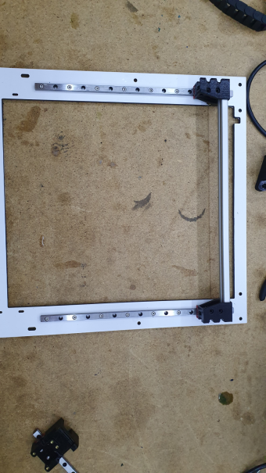

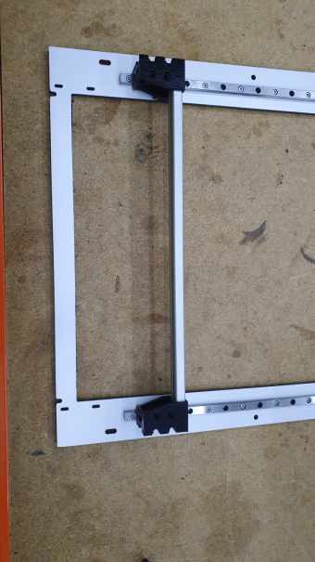

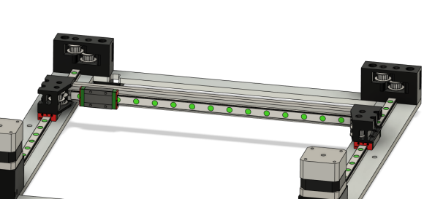

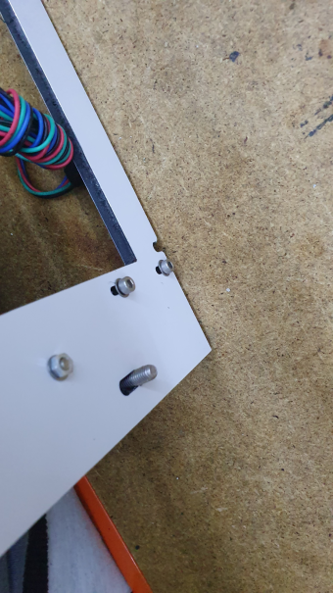

1x MGN9H 300mm rail with carriage

8x M3 T-Slot Nut

8x M3x8 cap head screw

Make sure, everything moves freely – if not: tram the xy-ganry

## X-carriage

1x x-carriage left

1x x-carriage right

2x x-belt-clamp

1x PL08N inductive Probe

2x M3 hex nut

2x M3x16 (probe)

2x M3x12 (belt clamp)

1x M3x35 cap head

4x M3x6 button head (x-carriage to MGN9H)

2x M2x12 (x-endstop)

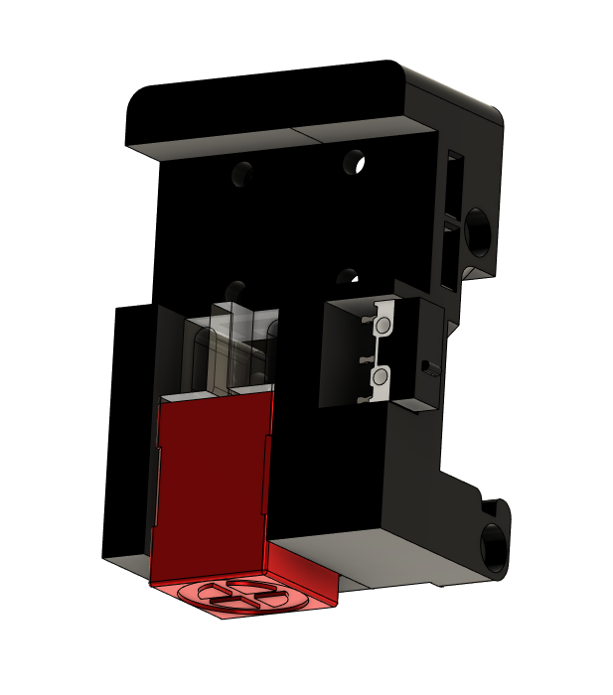

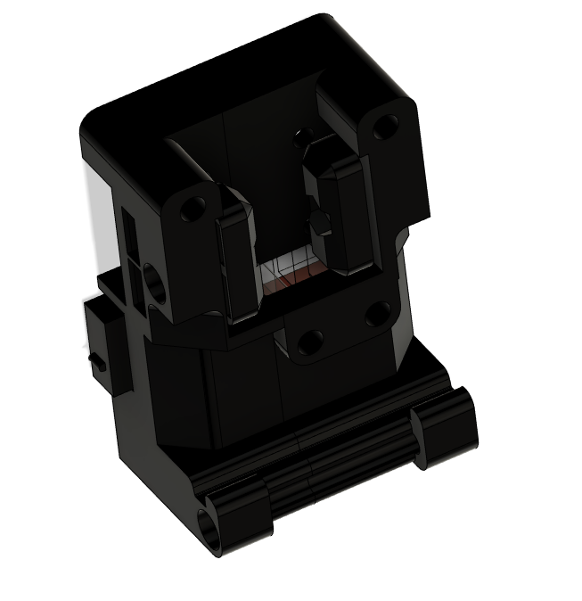

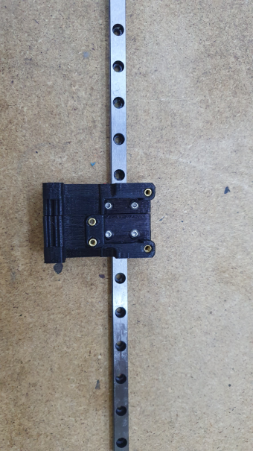

## Tool Head

Screws supplied with BMG-Extruder and E3D V6

2x M3x12 cap head (quick change)

6x M2x8 (4010 fans)

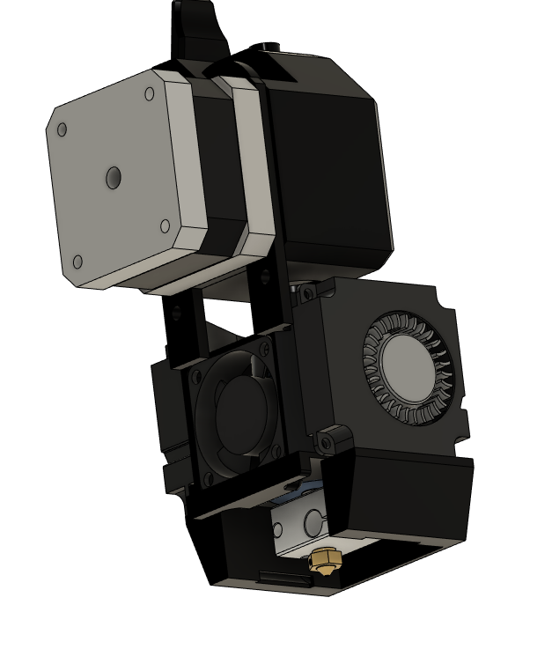

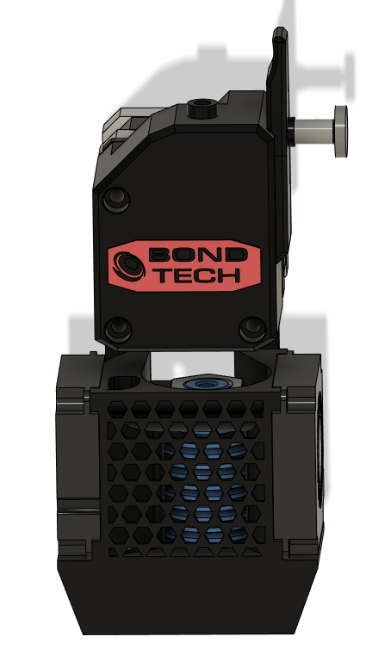

## Z-Motion Stage

8x GT2 20T pulley

4x GT2 20T pulley deflanged4

8x F695 2RS bearing

4x D=5mm, L=55mm rod

4x Nema17, L=40mm

20x M3x8 button head screw

16x M3x6mm cap head screws

8x M5x12

2x z-Drive motor Single

2x z-Drive motor Single MIRR

4x 80T hubbed gear

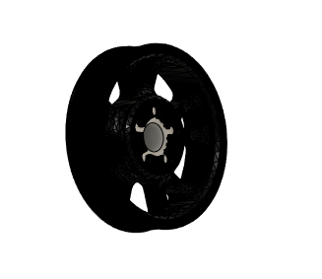

4x z-Belt-Tensioner

4x GT2 20T Idler, 3mm Bore

4x M3x16 cap head screw

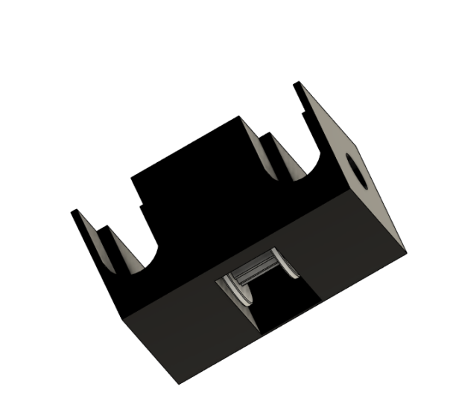

## Bed Assembly

1x BedPlate

1x BedPlate_Carrier

4x z_Belt_Clamp_A

4x z_Belt_Clamp_B

1x z-Dragchain_Mount_Bed

1x z-Endstop-Mount

4x LMK10LUU

10x M3x16 cap head

2x M3x18 cap

10x M3 hex nut

16x M4x12 cap head

16x M4 nut

4x M5x20 countersunk

Spacer di=5mm, l=10mm

4x M5 hex nut

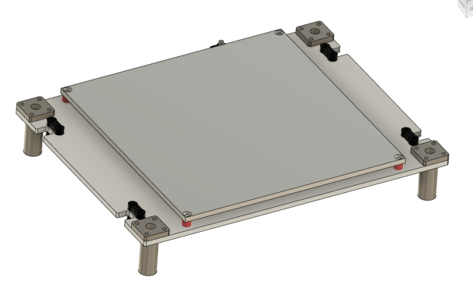

# Frame Assembly

## Main Frame

4x 2020x390mm aluminium extrusion with

1x xy gantry

1x front plate

1x back plate

12x M5x12 button head

